|  |  |  |  |  |  |  |  |  |  |  |  |
| --- | --- | --- | --- | --- | --- | --- | --- | --- | --- | --- | --- |
| cid:image001.jpg@01D2075E.A111E330 | | | | UE | |  | **UE CODE** | TU3.4 | | |  |
| **Topic** | |  | **Teacher** | **Alex.**  **Gazagnes** | | |  |
|  | Course evaluation | | | Practical Tests (R Software)  ISAFE -2024 | | Exam | **\*** |  |  |  |  |
|  | **Time** | |  | | | **Date** | **Avr 2024** | |  |  |  |
|  | *Calculator* | *Forbidden* | |  | *Documents* | *Forbidden* | | | |  | |
|  | *Allowed, but a basic one* | | *\** | *Allowed* | | | | *\** | |
|  | *Allowed* | |  | *Which documents?*  *Lectures, notes and laptops* | | | | | |

*LAST NAME: ……………………………………FIRST NAME: …………………………………TABLE:*

**The codes will be written in italics in the questions.**

Exercise 1 (4 points)

1. **Check if the line of code below is compiled in R. Correct if there is an error.**

*a=10 ; if (a%%2=0) print(a)*

Is the line of code correct?

|  |  |
| --- | --- |
|  | Yes ; |
|  | No. |

Correct the line of code if you answered No.

1. **Write an R expression that will return the sum equal to 10 for the vector *x = c(2, 1, 4, 2, 1, NA).***
2. **Check if the line of code below is compiled in R. Correct if there is an error.**

*hist(rnorm(10000,1,1), col=("purple","dark blue","blue","light blue","yellow","orange","red"), main="* *The most beautiful of graphics",breaks=seq(-7,7,0.1))*

Is the command correct?

|  |  |
| --- | --- |
|  | Yes ; |
|  | No. |

Correct the line of code if you answered No.

1. **Check if the line of code below is compiled in R. Correct if there is an error.**

*t.test(c(11,9,8,10,7,13,11),c(36.4,36.8,37.4,37.8,37.1,36.6,36.2))*

Is the command correct?

|  |  |
| --- | --- |
|  | Yes ; |
|  | No. |

Correct the line of code if you answered No.

Exercise 2 (6 points)

**Indicate in the boxes below the R codes to obtain the follow results / graphs.**

1)

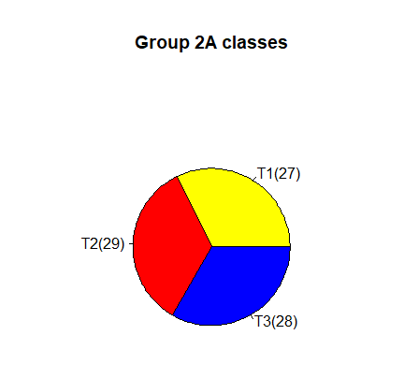

|  |
| --- |
|  |

2)

|  |
| --- |
| One Sample t-test  data: c(53, 32, 55, 20, 29, 18, 14, 2, 11, 6)  t = 2.4168, df = 9, p-value = 0.03881  alternative hypothesis: true mean is not equal to 10  99 percent confidence interval:  5.174627 42.825373  sample estimates:  mean of x  24 |

|  |
| --- |
|  |

3) Create a histogram with hatch. The densities of the hatched of the histogram must appear in the correct class!

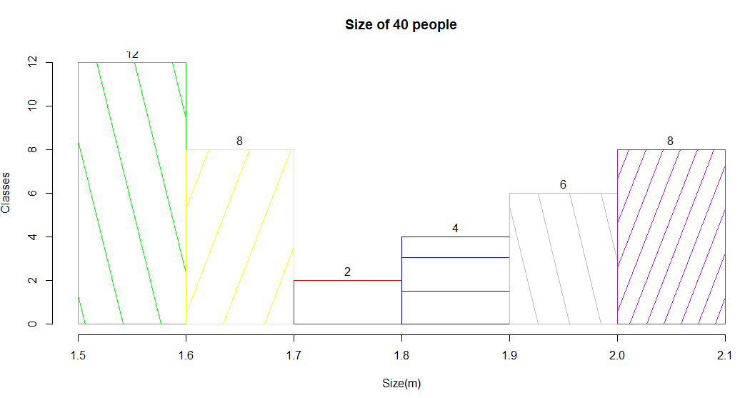

|  |
| --- |
|  |

Exercise 3 (10 points)

|  |  |  |
| --- | --- | --- |
| Sex | Group | Weight |
| F | T1 | 80 |
| F | T1 | 70 |
| F | T1 | 75 |
| M | T1 | 73 |
| F | T1 | 80 |
| M | T1 | 80 |
| M | T1 | 60 |
| F | T1 | 70 |
| M | T1 | 70 |
| M | T1 | 82 |

1. Indicate a command to save the table above in an object of type data.frame. Name it *Data*.

|  |
| --- |
|  |

1. Indicate a command to give all the information of the 4th individual of the data object.

|  |
| --- |
|  |

1. Indicate a command to calculate the average weight. Indicate the result.

|  |
| --- |
| Command: |
| Result: |

1. Enter the command to verify if “Group” is a numeric variable or not.

|  |
| --- |
|  |

1. Indicate a command to calculate the variance of the “Weight” and indicate the result.

|  |
| --- |
| Command: |
| Result: |

1. Specify a command to return all weight estimates given for women.

|  |
| --- |
|  |

1. Can we consider that the Weight variable of the dataset follows a normal distribution with the risk of % 5? Indicate a command to perform a statistical test under R. Indicate the p-value and the result obtained in R (corrected hypothesis).

|  |
| --- |
| Command: |
| p-value : |
| Corrected hypothesis: |

1. Do the groups of women and men have the same estimate of weight at risk of 1%? It is assumed that the variances are equal and that the populations are normal. Indicate one or more commands used to perform the statistical test under R. Indicate the p-value and the correct hypothesis.

|  |
| --- |
| Command: |
| p-value : |
| Corrected hypothesis: |

1. Enter a command in R that results in the information to complete the table below:

|  |  |  |  |  |
| --- | --- | --- | --- | --- |
|  |  | Women | Men |  |
|  | Frequency |  |  |  |
|  |  |  |  |  |
|  | | | | |